**MUHAMMAD NOMAN**

**ID: 35152**

**LAB: 01**

**Q#01: Write the address class next to each IP address.**

|  |  |
| --- | --- |
| **Classes** | **IP address** |
| **A** | **0-126** |
| **B** | **128-191** |
| **C** | **192-223** |
| **D** | **224-239** |
| **E** | **214-255** |

**Q#02 : step-3: Record the following TCP/IP information for this computer.**

1. **IP address**
2. **Subnet mask**
3. **Default gateway**

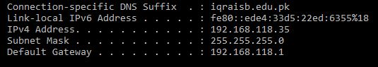

**Q#03**

**My Computer Data:**

IPv4 Address 🡪 192.168.118.35

Subnet Mask 🡪 255.255.255.0

Default Gateway 🡪 192.168.118.1

DNS Servers 🡪 192.168.1.5

**Computer’s Host Name: Anas – 33631**

IPv4 Address => 192.168.184.1

Subnet Mask => 255.255.255.0

Default Gateway => 192.168.118.1

DNS Servers => 192.168.1.5

**Part-B: using Ping Tracert:**

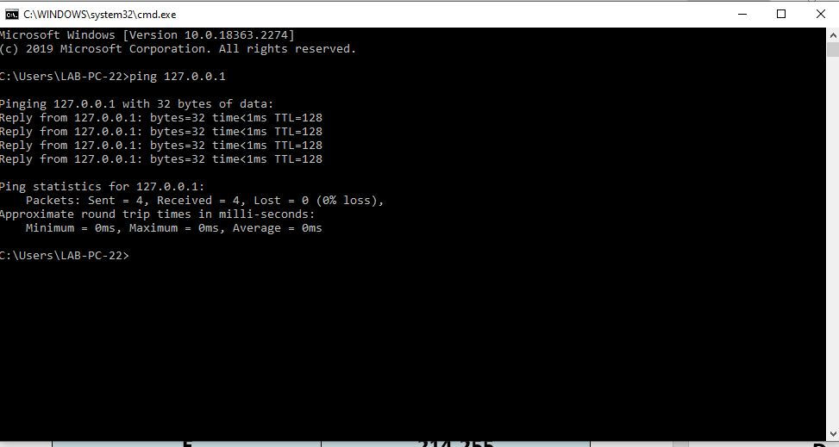

**Tracert**

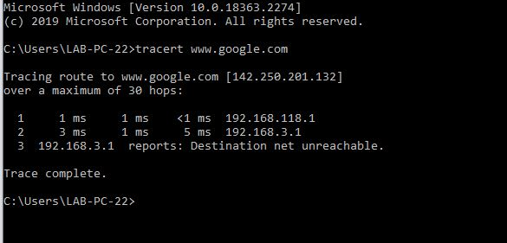

**Task 1:**

